**PROJECT DETAILS – LENSSHUB**

**1. HOME PAGE**

**Navbar(Box-1)**

**Container-1**

**Brand Heading(Box-3)**

**Container -2**

**Brand Title(Box-2)**

**2. ABOUT PAGE**

**Navbar(Box-1)**

**Container-1**

**Page’s Heading(Box-2)**

**Brand Details(Box-3)**

**3. ORDERS PAGE**

**Navbar(Box-1)**

**Container-1**

**Page’s Heading(Container-2)**

**Delivery Update Box(Container-3)**

**Delivery Update Box(Container-4)**

**4. STORES PAGE**

**Navbar(Box-1)**

**Container-1**

**Page’s Heading(Container-2)**

**Address Box-1(Container-3)**

**Address Box-2(Container-4)**

**5. SIGNUP PAGE**

**Navbar(Box-1)**

**Container-1**

**Page’s Heading(Container-2)**

**Sign Up Form(Container-3)**

**6. SIGNIN PAGE**

**Navbar(Box-1)**

**Container-1**

**Page’s Heading(Container-2)**

**Sign In Form(Container-3)**

**Page-1 Home Page**

**Elements** Created Container-1 which contains the Box-1 which is a Navigation Bar. Container-2, which contained two boxes Box-1 and Box-2, the Brand Title and the Brand Name.

**Styles** Styling started with resetting the Body CSS, styling Container-1 with fixing basic CSS like margin, height and font. Positioning it Relative so that I can position the Box-1. Styling Container-2 with appropriate width and height so that the page looks quite symmetrical. Used Classical Position to display elements in Container-2. Used proper animation property to display the Brand Name attractively.

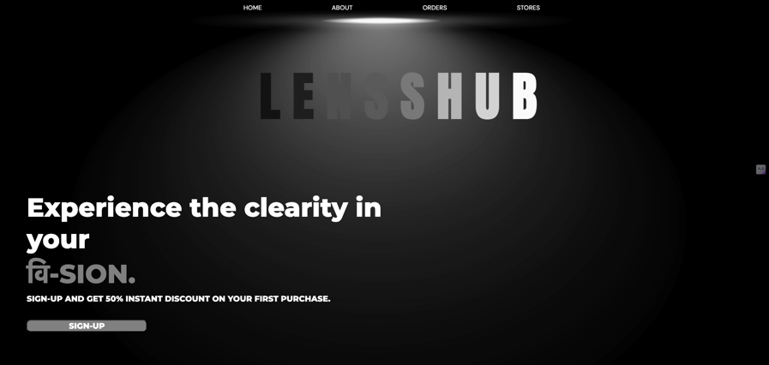



**Page-2 About Page**

**Elements** The About page is structured with three primary sections: **Container-1**, **Container-2**, and **Container-3**. **Container-1** houses the navigation bar, similar to the home page, for consistent site-wide navigation. **Container-2** features a striking heading with animated text, enhancing visual appeal. **Container-3** provides a detailed overview of the brand, including its mission, product offerings, and commitment to customer service.

**Styles** The styling starts with a body reset to ensure a consistent look across different browsers. **Container-1** is designed to mirror the home page's navigation bar, with a clean and centralized layout. **Container-2** incorporates a dynamic text animation effect, where each letter of the heading "ABOUT" fades in sequentially, adding a modern touch to the design. **Container-3** is styled with a dark background and rounded corners.

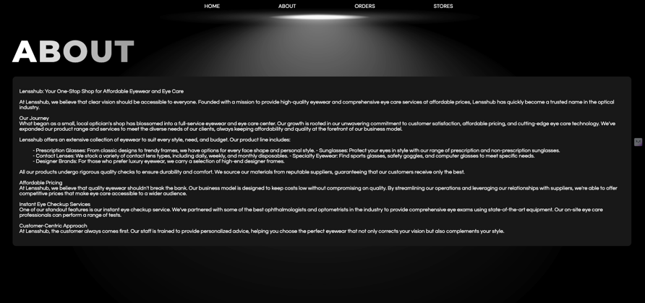



**Page-3 Orders Page**

**Elements** The Orders page is organized into several key containers. **Container-1** serves as the navigation bar, positioned at the top, with links to other pages like Home, About, Orders, and Stores. **Container-2** prominently displays the page heading "ORDERS" using animated and colourful text for visual impact. **Container-3** and **Container-4** present detailed order updates. Each of these containers includes product images, delivery dates, tracking information, sizes, and prices.

**Styles** The Orders page styling begins with a body reset, applying a consistent font and background image. **Container-1** maintains a compact height and centred navigation, ensuring ease of access. **Container-2** uses large, animated text for the heading, with each letter fading in sequentially. **Container-3** and **Container-4** feature dark backgrounds with light-coloured text and borders to enhance readability. Images within these containers have a subtle filter for visual consistency.

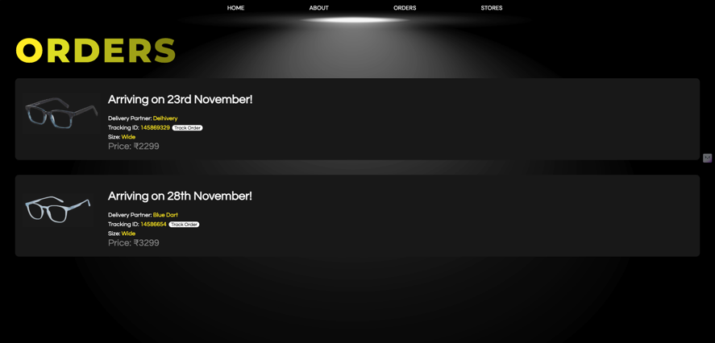

**Page-4 Stores Page**

**Elements** The Store page features several distinct sections. **Container-1** functions as the navigation bar, located at the top with links to Home, About, Orders, and Stores. **Container-2** displays the page heading "STORES" with animated, colourful letters. **Container-3** and **Container-4** provide address details for different store locations.

**Styles** The Store page styling includes a comprehensive reset for the body, setting margins and padding to zero and applying the 'Montserrat' font family. **Container-1** features a fixed height and centred navigation links with a clean layout. **Container-2** uses large, animated text for the heading, where each letter fades in sequentially with specific colour highlights. **Container-3** and **Container-4** have dark backgrounds with rounded corners and light-coloured text to ensure readability.



**Page-5 Signup Page**

**Elements** The Sign-Up page is organized into several main sections. **Container-1** serves as the navigation bar, including links to Home, About, Orders, and Stores. **Container-2** features the page heading "SIGN UP" with a colour gradient effect on each letter for a dynamic look. **Container-3** contains the core content, focusing on account creation. Within it, **item-1** includes a header, a link for existing users to sign in, a button for Google sign-up, and a form.

**Styles** The page uses a dark-themed background with a Montserrat font family for a modern feel. **Container-1** has a fixed height and centred navigation, while **Container-2** centres and animates the heading letters with a blur and fade effect. **Container-3** features a large, centred signup form in a rounded, dark box with padding. Buttons and input fields have a sleek, dark background with white text and rounded corners.

