This is the dashboard with global filters and charts. It has global filter which is applicable for all the charts.

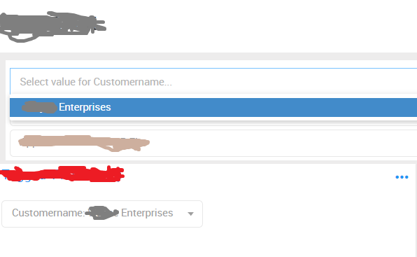

As we can see above it has only one value and first chart in the dashboard is also having one value.

Shown below is another chart (not first chart) in dashboard and it has 2 values as shown.

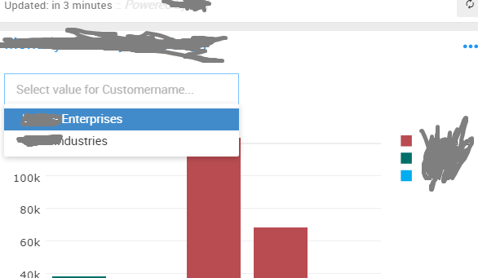

Ideally global filter should have 2 values by doing a union of all filter values. But here as per the first screen shot it is taking the value of first chart which is having only one filter.