Below is the screenshot for all the tasks I have added in the pipeline:

Few tasks are disabled for now.

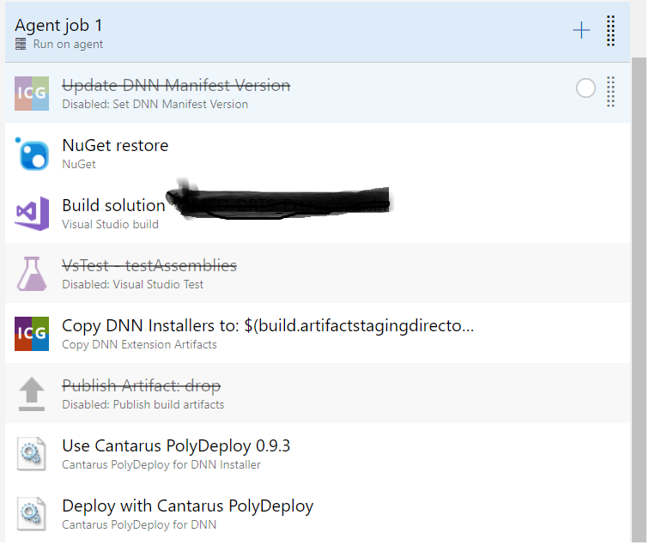

1. Nuget restore – to restore the packages.
2. Build Solution – to build the solution.
3. Copy DNN extension Artifacts – Store the install.zip file to some location i.e. $(build.artifactsstagingdirectory)
4. Use Cantarus PolyDeploy 0.9.3 – we are just giving the specific version of PolyDeploy to use. I kept it as 0.9.3 as of now. Below is the screenshot for the same:

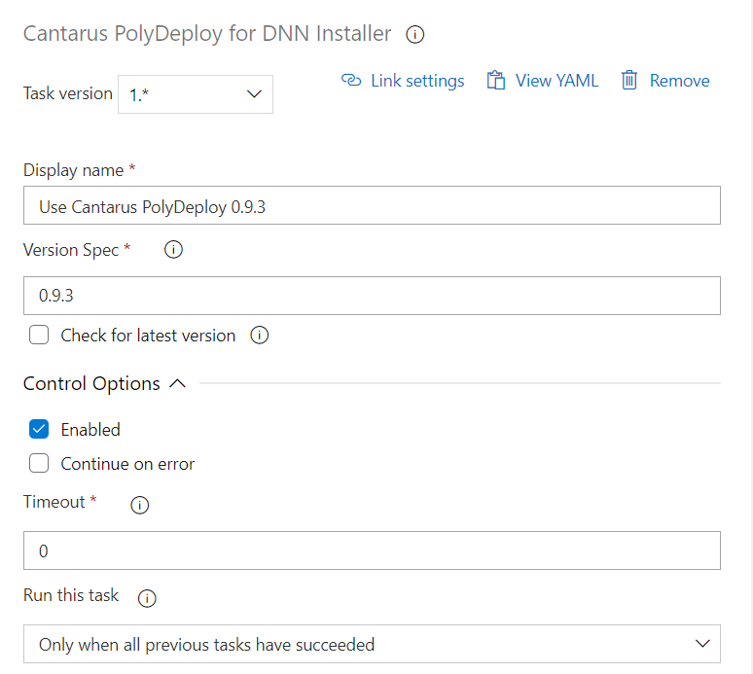

1. Deploy with Cantarus PolyDeploy – we need to provide the Deploy Path and other input parameters. Below is the screenshot for the same:

